Chapter 16, Solution 70.

Using Fig. 16.93, design a problem to help other students better understand how to do circuit analysis with circuits that have mutually coupled elements by working in the s-domain.

Although there are many ways to solve this problem, this is an example based on the same kind of problem asked in the third edition.

Problem

For the circuit in Fig. 16.93, find v_{o}(t) for t > 0.

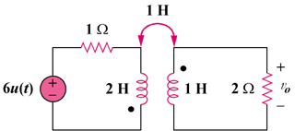

Figure 16.93
For Prob. 16.70.

Solution

Consider the circuit shown below.
s
2
I₂
s
2s
1
+
−
6/s
I₁

+

V_{o}

−

For mesh 1,
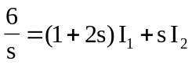 (1)

For mesh 2,
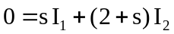
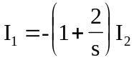 (2)

Substituting (2) into (1) gives
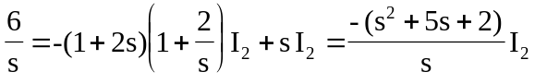
or 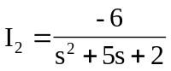

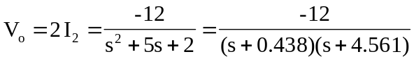

Since the roots of 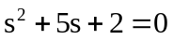 are -0.438 and -4.561,
 